Soft Matter 2007 solutions

1(a) The term Brownian motion refers to either
- The physical phenomenon where minute particles, immersed in a fluid or floating on its surface, move about randomly; or
- The mathematical models used to describe such random movements.
A description of a colloidal suspension in terms of Brownian motion is most appropriate at low densities because the positions of the colloidal particles are practically uncorrelated and the chance of finding a particle in any particular vicinity is almost independent of the presence of all the other particles.
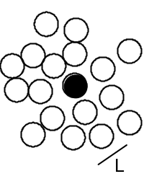
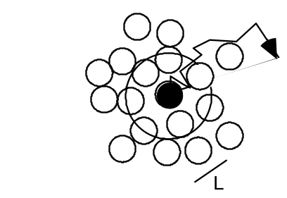
1(b) At high particle concentrations, their positions begin to become correlated as the
particles are mutually excluding. If we look inside a suspension of volume fraction φ ≥ 0.3, then we will find that, at any one instant, each particle is surrounded by a `cage’ of neighbours (short-ranged order). The cage tightens as φ increases. The cage size represents a dominant length scale in the system. Above φ ~ 0.3, different dynamical regimes are observed. At short times the particles diffuse with the short time (self) diffusion constant Ds. This is determined from the short time limit and is smaller than the D0 measured for dilute suspensions. The motion of the particles (self diffusion) is still driven by collisions with the liquid molecules, but in addition the interactions between particles become significant. While the particles are diffusing in their cages formed by their neighbours, the hydrodynamic interactions with the neighbours, transmitted through flows in the liquid, causes slowing down relative to the free diffusion at low concentrations. At intermediate times the particles encounter the neighbours and the interactions slow the motion down. To make further progress, the particle has to break out of the cage formed by its neighbours. Now the particles experience a further interaction, direct interactions (hard-sphere interactions), in addition to the hydrodynamic interactions. The long-time and long-ranged movement is also diffusive, i.e. we still have <r2(t)> ∝ t, when the particles undergo large-scale random-walk diffusion through many cages. However, the motion is further slowed and a smaller diffusion constant relative to the motion in the short time limit is observed, the long time (self) diffusion constant DL.

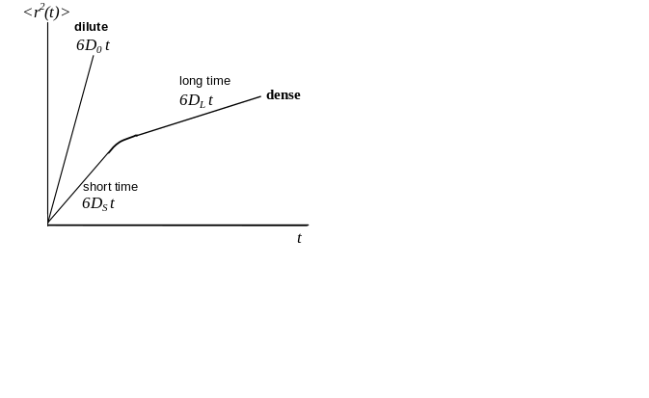

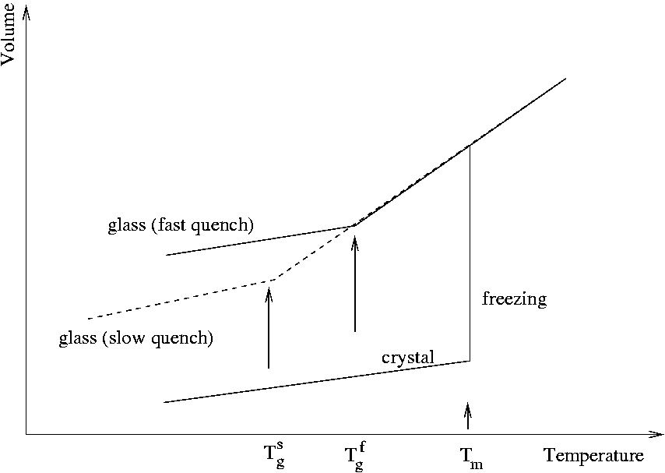
1(c) The glass transition temperature T_{g} is that temperature at which the system falls out of equilibrium on the experimental timescale τ_{exp}. Clearly therefore, if one does a long experiment, in which the temperature is lowered slowly, the system will have a greater time to relax at each successive temperature and will stay in equilibrium to a lower temperature. Thus the experimental glass transition temperature depends on the rate at which we do the experiment. To illustrate this consider a measurement of some structural quantity (such as the sample volume) as a function of temperature.
At. the glass transition temperature, the curve exhibits a well defined discontinuity in it slope, rather like what happens at an equilibrium phase transition such as freezing or boiling. The reason why the glass transition is not a true thermodynamic phase transition is that the temperature at which the discontinuity occurs depends on the history of the sample, i.e. how rapidly it is cooled. We say that the glass transition is a kinetic phase transition brought on by the divergence of the structural relaxation time.

1(d)
The experimentally measured viscosity and the associated configurational relaxation time of a glass forming substance exhibits a temperature dependence
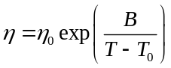

Where η is the viscosity, η₀ is the high temperature viscosity, B is a constant and T is the temperature, The empirical finding, known as the Vogel-Fulcher law implies that the viscosity diverges exponentially at the finite temperature T₀.

At low temperatures and high volume fractions, the local motion of neighbours is insufficent to allow a particle to diffuse or break out of its cage. Instead a number of neighbours must move cooperatively in order to make space for a molecule to move. The minimum number of molecules that have to move in unison in order for diffusion of a molecule to take place gives rise to the concept of a cooperative rearranging region. As the temperature is lowered the size of this region increases, diverging (with the viscosity) at the Vogel-Fulcher temperature T₀

2(a) In a Theta solvent the effects of excluded volume (trying to swell the chain) and attraction (trying to collapse the chain) cancel out and the chain has ideal dimensions and is described by random walk behaviour. Its end to end distance (and also the gyration radius) therefore obey the scaling 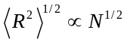

2(b) We consider the Helmholtz function of a single chain, which is regarded as an assembly of particles with constant volume NV1 at constant temperature T, where V₁=b³ (the monomer volume):
F = U - TS
The entropy S is given by
S = kB ln(no. of configurations)

where for a given R the number of configurations is expected to be proportional to
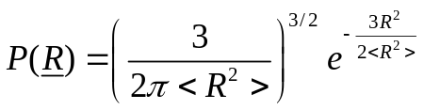
and hence
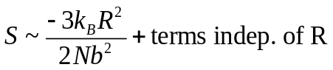
The internal energy U includes the kinetic and potential energy. However, the kinetic energy is independent of the configuration and thus of R and we only have to consider the potential energy. To estimate the potential energy, we disregard the connectivity of the chain and calculate the interaction energy of a 'segment gas' confined in a volume R3. The probability of a monomer to lie in this volume is given by the fraction of total coil volume occupied by monomers, which we estimated above to be 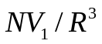. Thus the probability of monomer-monomer contacts is 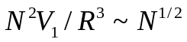. With an energy ε of a monomer-monomer contact, the potential energy 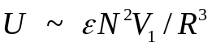.
We thus obtain
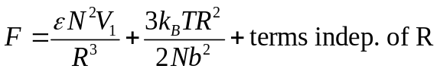
which can be minimized with respect to R, i.e. dF/dR = 0, yielding
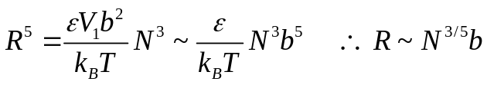

2(c) Dilute: The polymer coils are well-separated on average, meaning:
concentration in
mass per volume
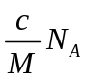 | X | 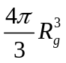 | << 1
number per volume |  | volume of  one coil
volume fraction of coils

Semi-dilute:
The concentration is larger than the overlap concentration c*, but still much smaller than the bulk density. The coils interpenetrate and entangle, but the solution is still mostly solvent

Concentrated:
In this case the concentration is very close to the bulk density and the polymer monomers occupy a significant fraction of the total volume.

2(d) Most everyday plastics are thermoplastics. At high temperature the free energy is dominated by the entropic terms. The melt resembles a random assembly of mobile, intertwined, flexible coils with a density similar to the density of the corresponding monomer liquid. Upon cooling the potential energy takes over and the bonds are restricted in their rotation leading to configurations which are more straightened out. Below the melting temperature Tm, a crystal is the lowest free energy state. Crystallisation, however, requires significant ordering of the initially random melt and is only possible if cooling occurs slow enough. If the melt is rapidly cooled below the glass transition temperature Tg (< Tm), then instead of a crystal a glass is formed, which represents an amorphous metastable, but long-lived state. Although the polymers can still vibrate, they can no longer move. Solid thermoplastics are frequently a mixture of crystalline and amorphous structures.

